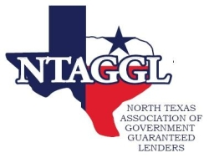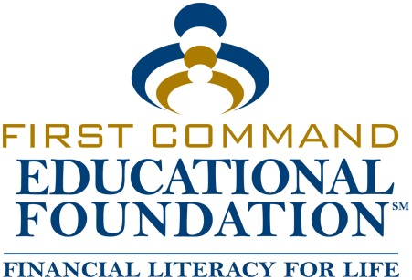
APPLICANT SUBMISSION AND PROCESSING PROCEDURES
A. FOR APPLICATION, PLEASE REFER TO THE WEB-SITE OF NTAGGL.ORG WHERE APPLICATION AND REQUIREMENTS HAVE BEEN MADE AVAILABLE, “AS A DOWNLOAD ITEM”.

B. UPON DOWNLOADING THE PACKAGE, PLEASE COMPLETE THE APPLICATION IN ITS ENTIRETY AND PROVIDE ALL REQURESTED INFORMATION. INCOMPLETE APPLICATIONS WILL NOT- BE- ACCEPTED.

C. SUNDAY, APRIL 28, 2024 AT 11:59 PM IS THE DEADLINE DATE FOR SUBMITTING APPLICATIONS FOR THE 2024 FALL – SEMESTER.

D. PREVIOUS APPLICANTS AND RECIPIENTS CAN REAPPLY FOR THE SCHOLARSHIP. PREVIOUS RECIPIENTS WHO REAPPLY WILL RECEIVE NO EXCEPTIONAL CONSIDERATION.

E. APPLICATIONS WILL BE UPLOADED TO THE SECURE PORTAL AS RECEIVED FOR SCREENERS TO REVIEW.
F. AS APPLICATIONS ARE RECEIVED, THEY WILL BE REVIEWED BY TWO NTAGGL “SCREENER COMMITTEE MEMBERS” FOR COMPLETENESS AND ELIGIBILITY UNDER THE GUIDELINES AS POSTED ON THE NTAGGL WEB-SITE NO LATER THEN, SUNDAY, MAY 19, 2024.

G. ALL ELIGIBLE APPLICATIONS ACCEPTED,”AS ELIGIBLE” BY “SCREENERS” WILL BE FORWARDED TO THE “FIVE SELECTION MEMBERS” AS RECEIVED, FOR REVIEW AND SCORING.

H. UPON COMPLETION OF REVIEW AND SCORING, EACH “SELECTION MEMBER” WILL RETURN EACH REVIEWED AND SCORED APPLICATION TO THE “CHAIR COMMITTEE” FOR SELECTION OF THOSE APPLICATIONS THAT RECEIVED THE HIGHEST SIX (6) SCORES (AVERAGE OF THE SCORES RECEIVED BY EACH OF THE FIVE SELECTION COMMITTEE MEMBERS OF EACH APPLICANT).

ELIGIBLE REVIEWED AND SCORED APPLICATIONS WILL BE RETURNED TO “THE CHAIR COMMITTEE” VIA NTAGGL SECURE PORTAL NO LATER THEN, SUNDAY, JUNE 23, 2024.

I. THE “CHAIR COMMITTEE” WILL AVERAGE THE SCORES OF EACH APPLICANT AS DETERMINED BY THE “FIVE SELECTION COMMITTEE MEMBERS” NO LATER THEN, SUNDAY, JUNE 30 2024. THE WINNERS WILL BE FORWARD TO FIRST COMMAND EDUCATIONAL FOUNDATION “FCEF” NO LATER THEN, FRIDAY, JULY 5, 2024.

J. ANNOUNCEMENT OF THE TOP SCORING APPLICANTS WILL BE MADE BY NTAGGL AND THE PROCEEDS OF THE $1,000.00 SCHOLARSHIPS WILL BE MADE DIRECTLY TO THE COLLEGE OR UNIVERSITY OF THE AWARDEE BY FCEF. THE AWARDEE WILL BE ANNOUNCED AT THE JULY LUNCHEON DATE TO BE DETERMINED, 2024.

The NTAGGL process for approval does not discriminate on the basis of race, culture, color, creed, gender, religion, or sexual orientation. Awards are $1,000 and will be made directly to the college/university and applied to the recipient’s account.

